SOA EXPERIMENT – 2
API Gateway for E-Commerce Routing

1)AIM:-
To develop an API Gateway for an E-Commerce application using Spring Cloud Gateway. The gateway acts as a single entry point for client requests and routes requests to the appropriate backend services based on the requested URL path.
2)OBJECTIVE:-
The main objectives of this experiment are:
- To create an API Gateway using Spring Boot and Spring Cloud Gateway.
- To configure routing for different E-Commerce services.
- To route product-related requests through the Product Service route.
- To route cart-related requests through the Cart Service route.
- To test the configured API Gateway using Postman.
- To verify the health status of the Gateway using Spring Boot Actuator.

3) TECHNOLOGIES USED:-
- Java 17
- Spring Boot 3.5.15
- Spring Cloud Gateway
- Spring Tools for Eclipse
- Maven Postman
- DummyJSON API as the external service used for testing

4)PROJECT CREATION USING SPRING TOOL:-
Step1:- Open Spring Tools for Eclipse. Create a new Spring Boot project.
The project details used for this experiment are:
Project Name: SOA_gateway
Group: com.example.demo
Artifact: SOA_gateway
Packaging: Jar
Java: 17
Spring Boot: 3.5.15
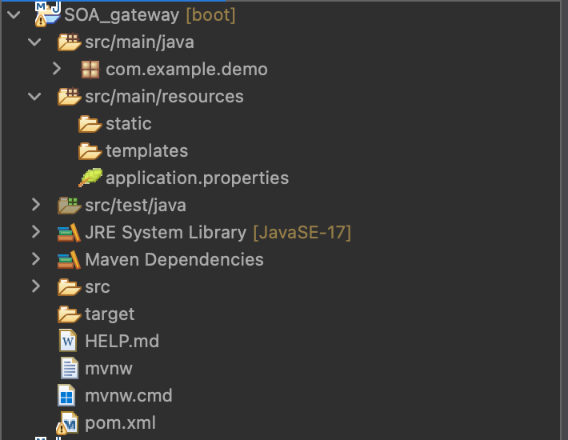

Step2:- open pom.xml and write this code:-
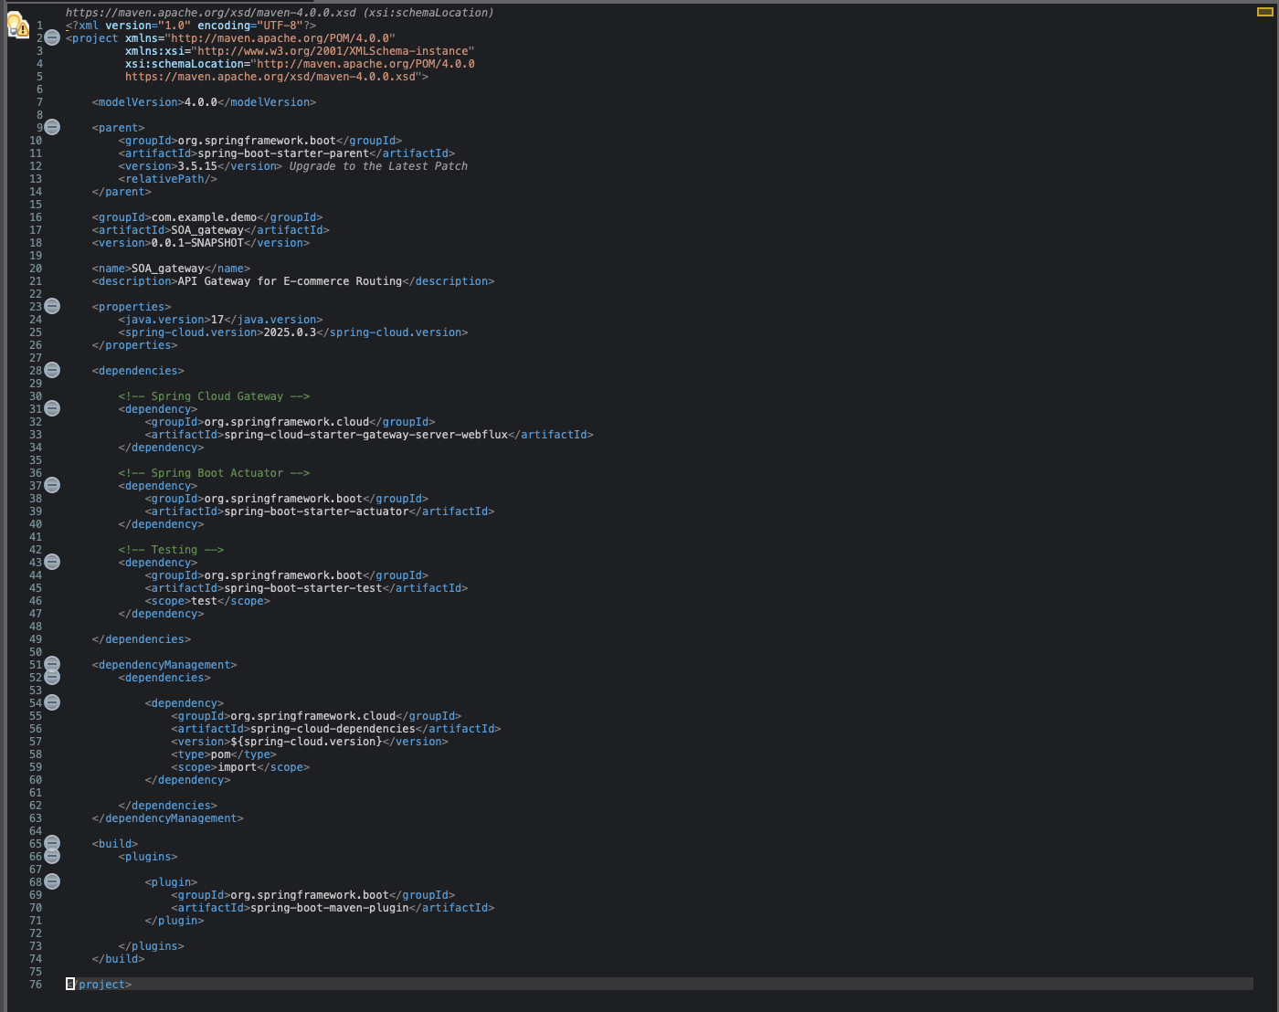

Step3:- now go to
src/main/java
↓
com.example.ecommerce
↓
EcommerceGatewayApplication.java
-> and change the code:-
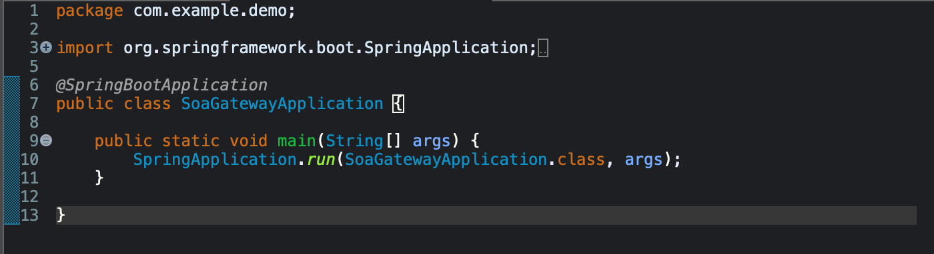

Step4:- change the application properties
src/main/resources
↓
application.properties
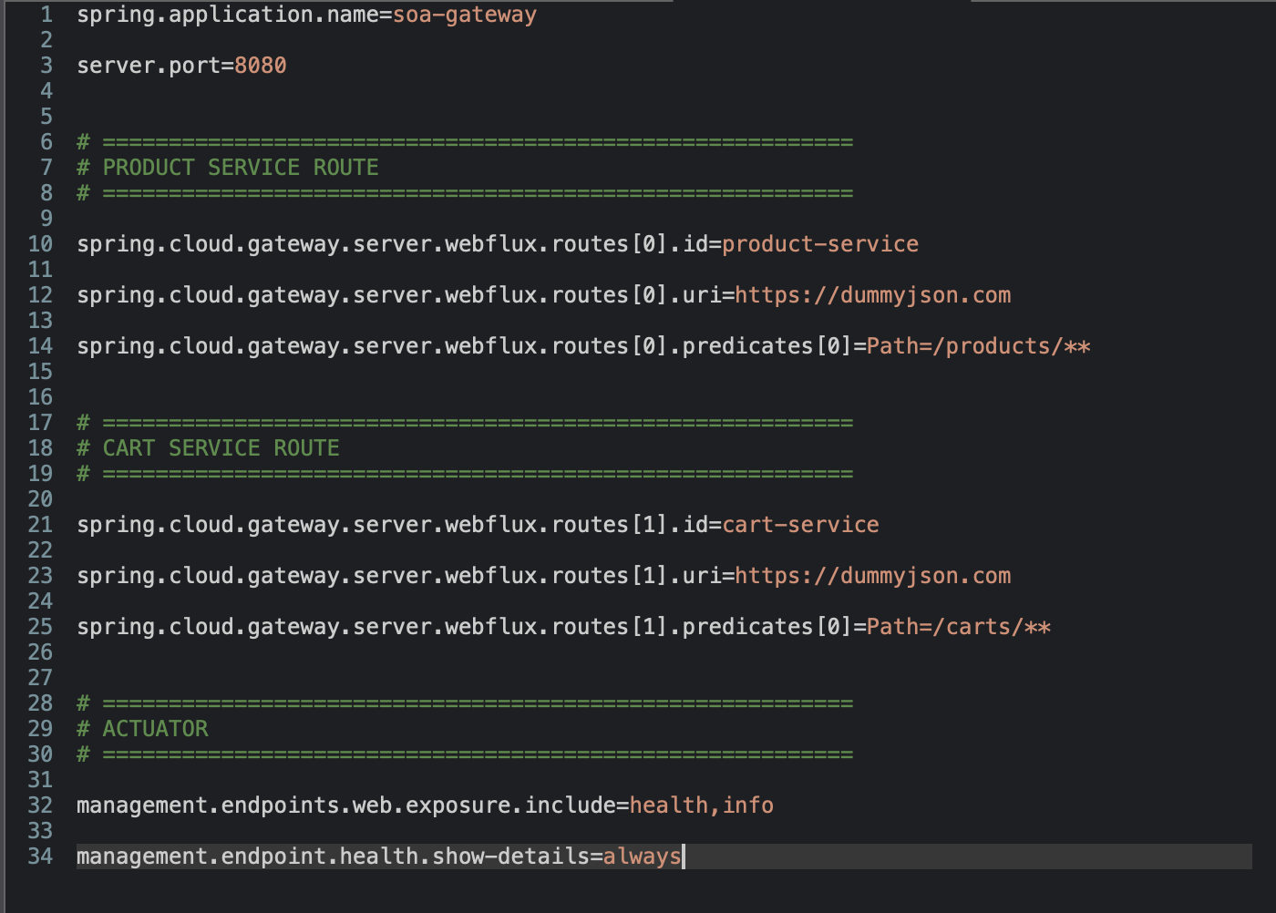
Step5:- save everything using “cmd+S”
Step6:- Then right-click the project: Maven → Update Project
Step7:- Run the project
right click: EcommerceGatewayApplication.java
Then: Run As → Spring Boot App
Now you need to see Started EcommerceGatewayApplication in the console.
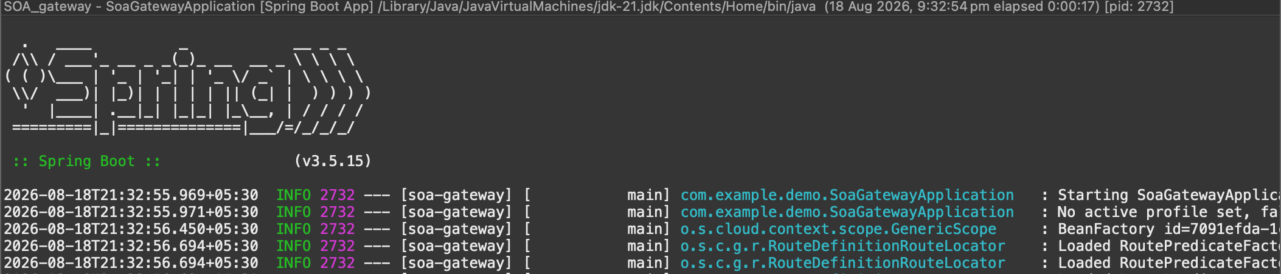

Step8:- Now Postman — Product API|
open postman : create – “GET” operation
URL:- http://localhost:8080/products/1 click send
output:-
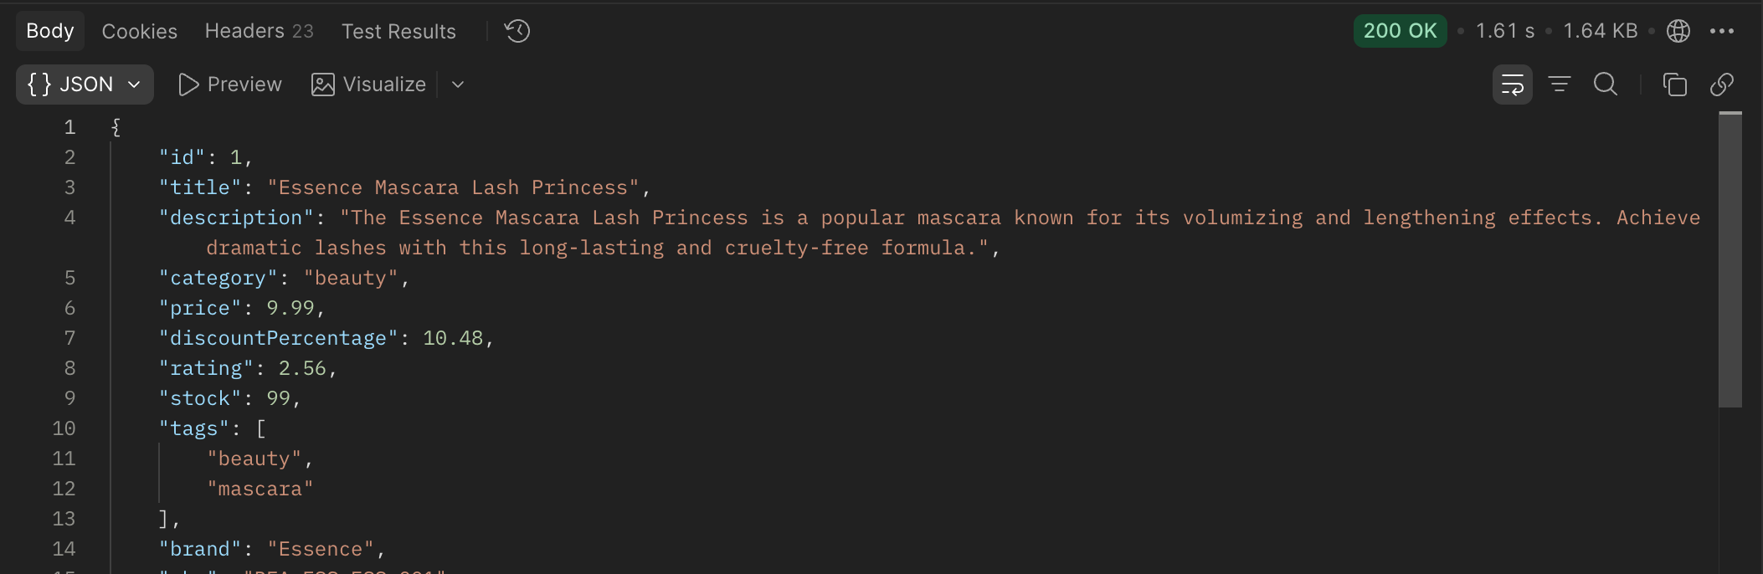

Step9:- product test 2
in the “GET” operation
URL:- http://localhost:8080/products/2 click send
Output:-
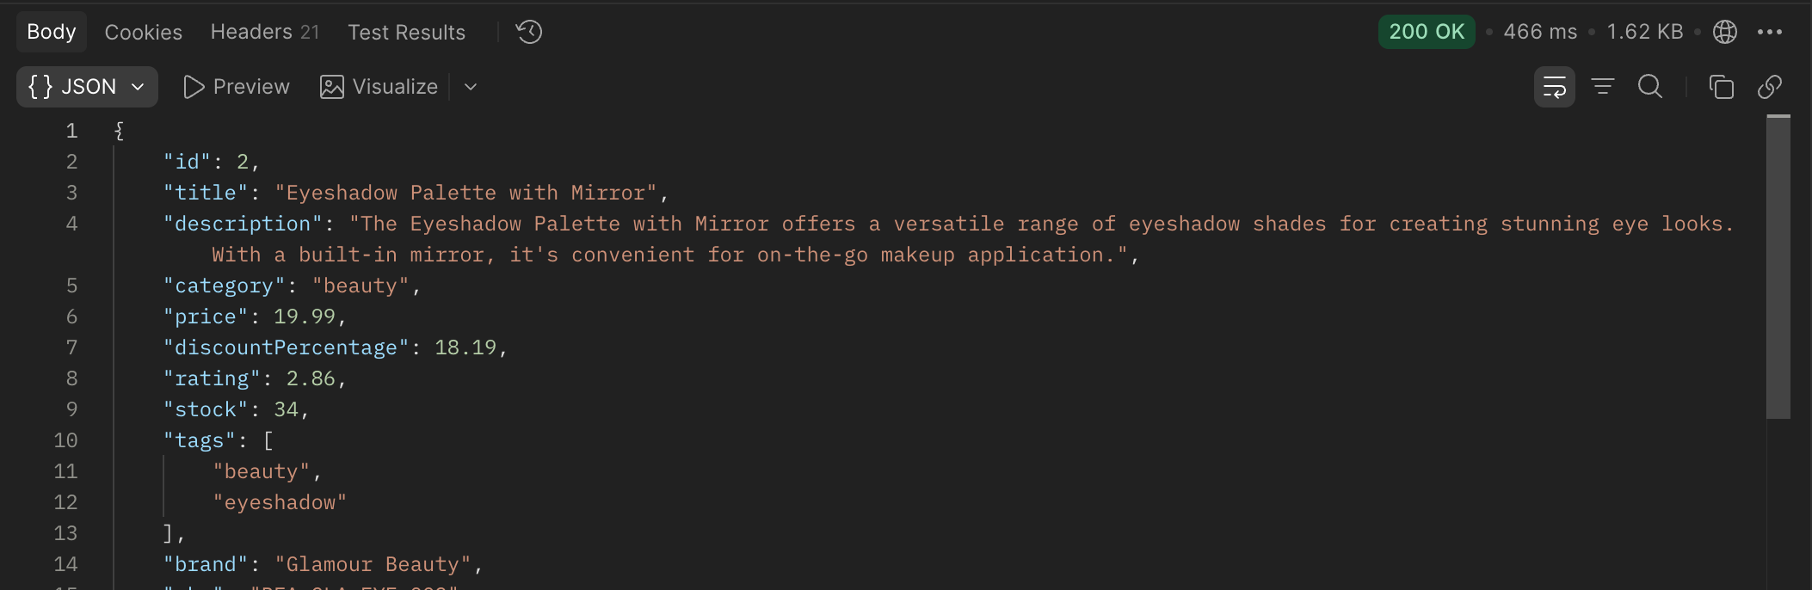

Step10:- Cart API
create a new request:-
GET - URL:-http://localhost:8080/carts/1
Output:-
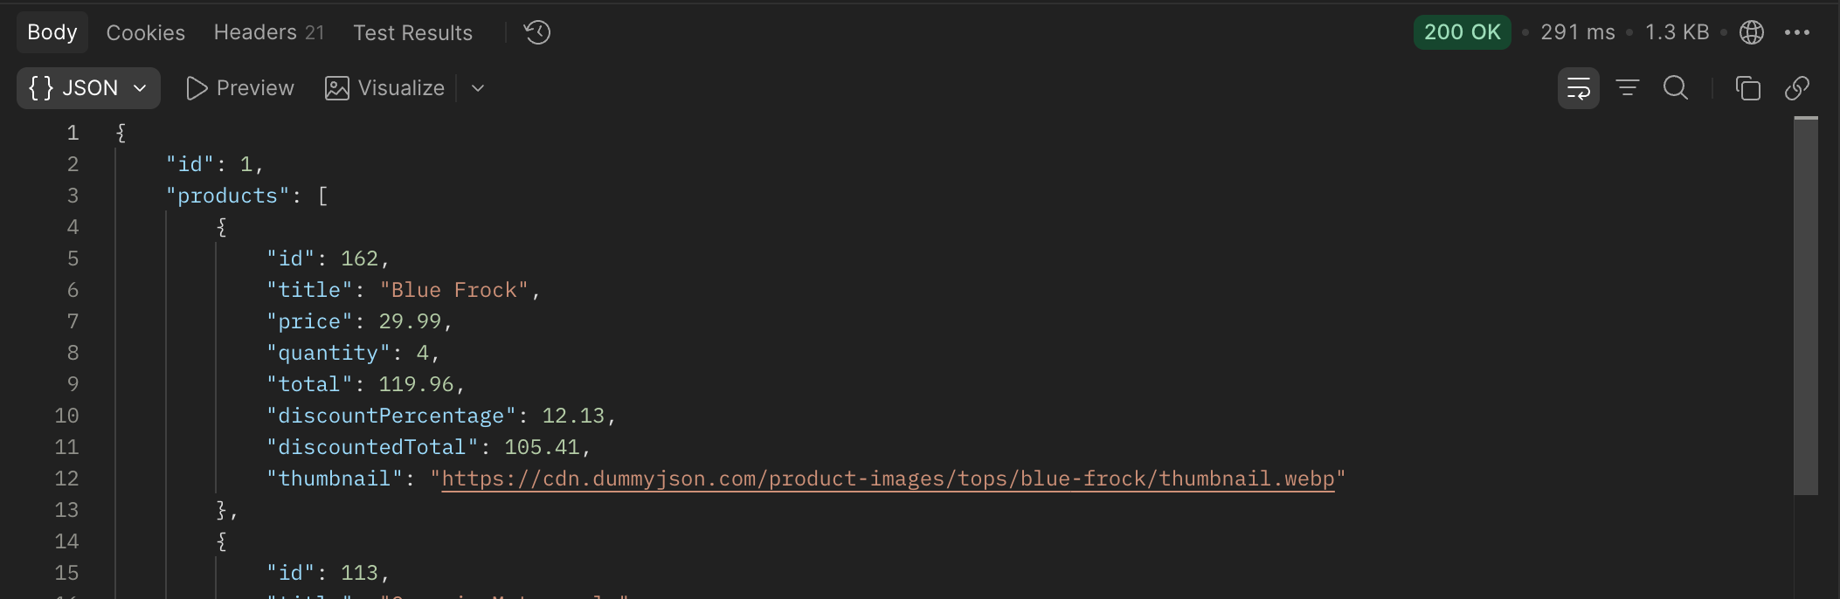

Step11:-Cart test 2
GET- URL:-http://localhost:8080/carts/2
Output:-
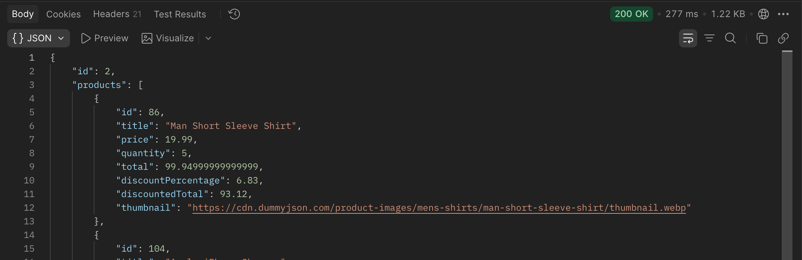
Step12:- test the invalid route
GET- URL:-http://localhost:8080/orders/1
Output:-
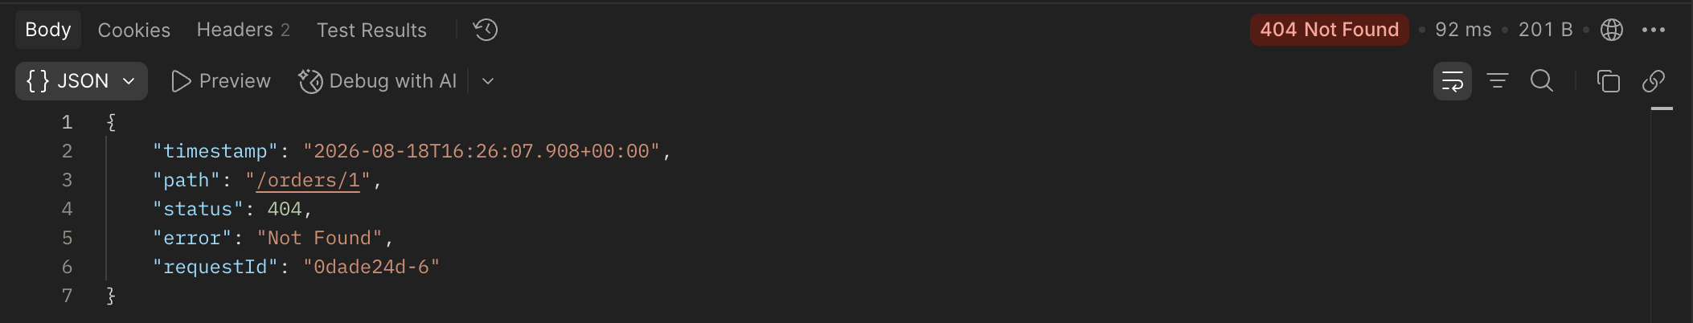

Step13:-health check
GET- URL:- http://localhost:8080/actuator/health
Output:-
